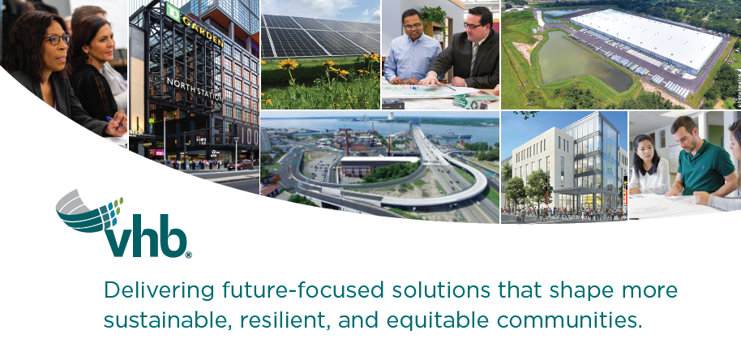
ABOUT THE POSITION
VHB’s Site Investigation and Remediation team is seeking an entry-level Environmental Scientist, Geologist or Environmental Engineer to join our Providence, RI office. At VHB we are passionate about making meaningful contributions to the world through the work that we do. If you’re interested in making a positive impact, opportunities to grow personally and professionally, and making smart new friends – we’d love to have you join us.
Responsibilities
- Field data collection (soil, sediment, groundwater, surface water, soil gas sampling)
- Conduct Site Investigations including ASTM Phase I and II Environmental Site Assessments Leveraging technology to support data management and visualization
- Conduct and Document Research at State and Municipal Agencies
- Provide Field Support and Documentation of Remediation Projects
- Write Technical Reports, Correspondence, Notes and Memoranda
Skills and Attributes
- Ability to work in field and office settings
- Excellent verbal, written and interpersonal communication skills
- Motivated and ability to problem solve and work independently
- Working knowledge of MassDEP and RIDEM hazardous materials regulations and guidance documents a plus.
- Prior experience with SPCC and SWPPP inspections also a plus.
Qualifications
- BS in Geology, Hydrogeology, Environmental Science, or Environmental Engineering (MS preferred)
- 0-1 years of professional environmental/remediation consulting experience
- OSHA 10-Hour Construction and 40-Hour HAZWOPER certificates required after 30 days of employment

WE ARE VHB! We’re an inspired and innovative team of engineers, scientists, planners, and designers who partner with clients in the transportation, real estate, institutional, and energy industries, as well as federal, state, and local governments.

Our work helps improve mobility, enhance communities, and contribute to economic vitality. We do this while balancing development and infrastructure needs with stewardship of our environment.

Our people make us great! VHB provides a differentiating employee experience.
- Inclusive culture of collaboration and innovation
- Opportunity to work on complex, transformational projects
- Amazing co-workers
- A focus on learning and development
- Flexible, hybrid workplace
It’s not surprising that VHB has consistently been rated one of the top AEC firms to work for across our 30+ offices on the East Coast. We’re growing and we hope you’ll join us!
VHB is proud to be an Equal Opportunity/Affirmative Action Employer. All qualified applicants will receive consideration for employment without regard to race, color, religion, sex, sexual orientation, gender identity, national origin, disability or veteran status, age or any other federally protected class.

#LI-DF1

